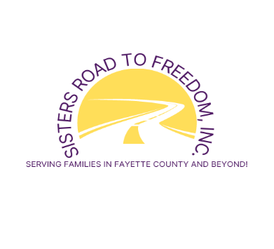
P.O. BOX 1084, LEXINGTON, KY 40588-1084
Tel. No. (859) 536-7677
E-mail: sistersroadtofreedominc@gmail.com
Website: www.sistersroadtofreedom.org
paypal.me/SistersRoadToFreedom

LIST OF NEEDS:

*Tax-deductible Cash/Check: dedicated solely for the rent/utilities (payable to Sisters Road To Freedom, Inc., P.O. Box 1084, Lexington, KY 40588-1084)

*Non-Perishable Food: Cereals, Mashed Potatoes, Macaroni & Cheese, Stuffings, Peanut Butter, Pancake Mix, Dry Milk, Green beans, Corn/Sweet Corn, Sweet Potatoes, Potatoes, Soups, Spaghetti, Spaghetti Sauce, Beans

*Gift cards:
Kroger/Meijer/Wal-Mart

*Household Items:
Laundry Detergent, Toilet Paper, Dish Washing Liquid, Paper Towels

*Hygiene Products:
Deodorants, Soap, Shampoo, Hand/Body Lotion, Toothbrush, Toothpaste, Mouthwash

Physical Location: Co-Heirs For Christ Building
2350 Woodhill Drive, Suite 68, Lexington, KY 40509

Serving Families In Fayette County and Beyond!!!

